Free Drawing Activities to Improve Children's Art at Ra Alkaromah Pandan Sekarmojo Purwosari Pasuruan

Nurhayati 18.48.0094
Institution: College of Tarbiyah NU Al-Hikmah Mojokerto
e-mail: hnur64014@gmail.com

Abstract:Free drawing is making an image by scribbling, scratching, incising sharp objects to other objects and giving colors to create an image. This research is a qualitative research. Data was collected by means of structured interviews, observation, and documentation. Data analysis was carried out by data triangulation, namely comparing the three existing data sources and then drawing conclusions from the data obtained. The results of this study indicate that providing freedom in drawing can increase children's creativity and imagination and also develop feelings and skills when children do drawing activities, because drawing is a medium for early childhood to play while learning is more fun and interesting.

Keywords:Creativity, Free Drawing, Early Childhood

PRELIMINARY
Creativity is important, especially in early childhood, because with creativity children can manifest themselves. This realization is one of the basic needs in a child's life. Every child has a desire to create something. Existing desires and abilities are stimulated and nurtured. So that children get the ability to create something, feel satisfied with the results of their creation and make children more creative. The purpose of developing children's creativity (in Montolalu, 2007:35) is (1) to introduce how to express themselves through their work using the techniques they master. (2) Introducing ways to find alternative solutions to problems. (3) Making children have an attitude of openness to various experiences with a level of flexibility. (4) Making children have self-satisfaction with what they do and an attitude of appreciating the work of others. (5) Making children creative, namely originality in generating thoughts, elaboration of ideas, tenacity and patience or persistence in facing obstacles and uncertain situations.
The experience of creativity will teach children to be open and children to get self-satisfaction with what they do and produce. Efforts to create an atmosphere conducive to the development of creativity is only possible if we first understand the nature of creative abilities and the surrounding environment. According to Allen (in Nuraini & Bambang, 2010:40) Creativity can be generated through problems that spur creative behavior, including first, fluency (fluency); second, flexibility (flexibility); third, originality (authenticity); fourth, elaboration (details); fifth, sensitivity.
The reason creativity is important to be raised, nurtured, and developed in children is because by being creative children can manifest themselves, with creative thinking skills it is possible to see various kinds of problem solving, being busy creatively will give satisfaction to individuals, with creativity allowing humans to improve their quality. his life. Free drawing is a two-dimensional art activity that can develop children's artistic and creative skills. As stated by Indarti (2005:4) that by drawing children can express their expression and imagination without limits. In this process, children can develop ideas, channel emotions, grow their artistic and creative interests and skills.
Drawing for children is a form of creative expression and imagination. By drawing children will bring up creative ideas and imagination will affect the creativity that he has. Rohidi (2001: 120) that the world of art is a world of imagination, so when children tell their imagination into the form of a work of art, namely by drawing, it is a form of children's creativity. Creativity in free drawing does not only exist in the field of developing basic art skills but also in all areas of developing other basic abilities, namely cognitive, language, social emotional, and physical motor skills.
The teaching and learning process that occurs in free drawing activities is in fact still directed by the teacher and the theme is determined in each activity. Free drawing activities are also rarely done, teaching and learning activities are more about teaching children to learn to count and read. Because the teacher is based on an activity plan that has been made from the past which in essence teaches more children to read and count.
This can be seen when doing free drawing activities, children lack ideas and cannot express their own ideas, lack of courage, spontaneity and freedom in expressing the turmoil of feelings, ideas and imagination. Therefore free drawing activities really need to be developed to help develop children's creativity and through free drawing children will also get a fun experience.

METHOD
This type of research is qualitative. The target in this study was children aged 5-6 years. Data collection techniques are observation techniques, field notes, interviews, documentation. The instrument in this research is the researcher as the main instrument, and the auxiliary instrument is data tabulation. The data in the study were analyzed by qualitative descriptive analysis method, namely the words obtained were interpreted by reading the data, finding the data, identifying the data, classifying the data, analyzing the data, and synthesizing the data.

RESEARCH RESULT
The researcher will describe the focus, namely the influence of drawing activities on the creativity of children aged 5-6 years at RA Alkaromah Pandan. This study uses a qualitative method and a descriptive approach. Qualitative methods are often called naturalistic research methods because the research is carried out in natural conditions (Sugiyono, 2009). In qualitative research, researchers are required to be able to dig up data based on what is said, felt, and done by the data source. In qualitative research, the researcher is not what the researcher thinks but is based on what is happening in the field, experienced, felt, and thought by the data source. By conducting research through a descriptive approach, the researcher must describe, explain,
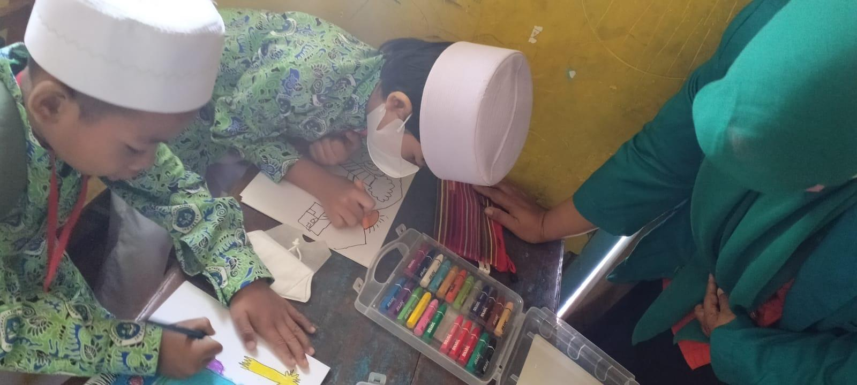
The research data in this study were obtained through in-depth interviews conducted by researchers over a period of 1 month. Where all the informants who conducted in-depth interviews were school principals and classroom teachers. Based on in-depth interviews conducted by researchers with the informants of the RA Principal and the homeroom teacher, namely regarding creativity in children in drawing, it was found that the efforts of classroom teachers in introducing creativity to children are by always motivating children, however, here the teacher is still unable to develop creativity in children. children, because the teacher still uses their daily learning activities as usual and in drawing activities the children are still directed / still given examples in advance in drawing learning activities.
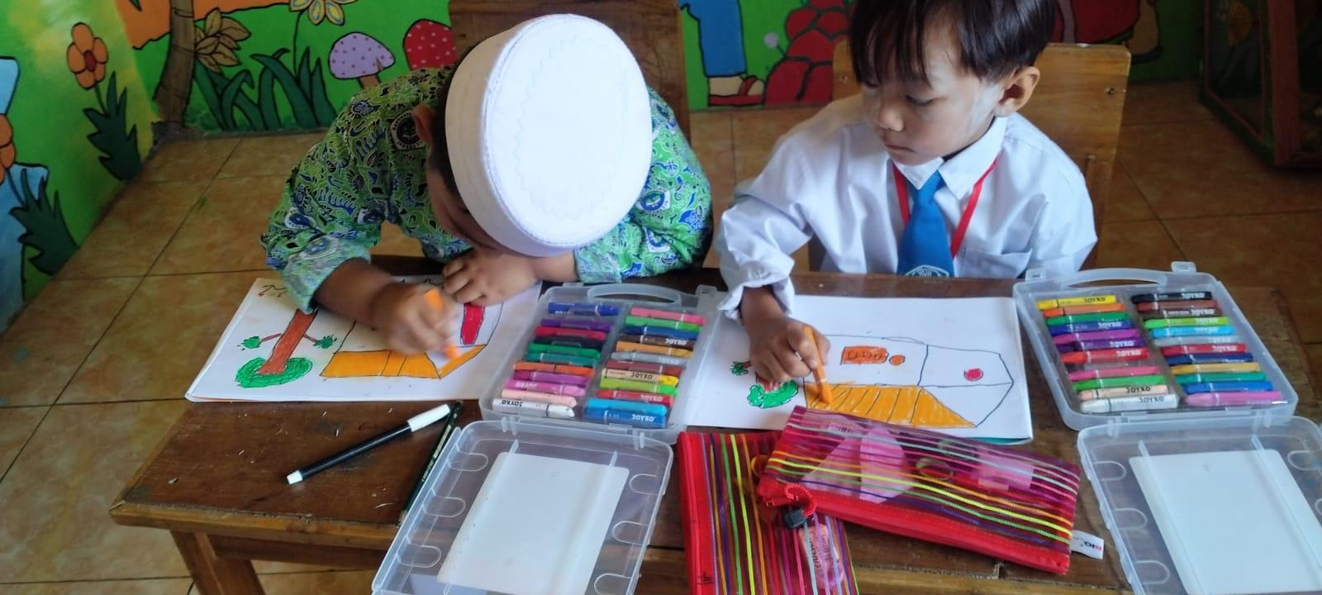
Teachers still have not tried drawing activities to develop creativity in children. The media used to introduce drawing creativity is that it still uses simple media and children are still directed/accompanied when a drawing activity begins and they still have to be given examples first in every time they want to draw. Teachers still have difficulty in drawing activities, because children are still not able to develop their own creativity/imagination and are still confused about pouring their ideas into pictures, therefore teachers still have to help children and need to accompany them.
The students are still not enthusiastic in drawing activities, because for children drawing is very easy and has been done often. For this reason, children need special motivation and equipping so that they understand that what they draw is their own creativity, and not just drawing into a picture book, so children get bored quickly when there are drawing activities.
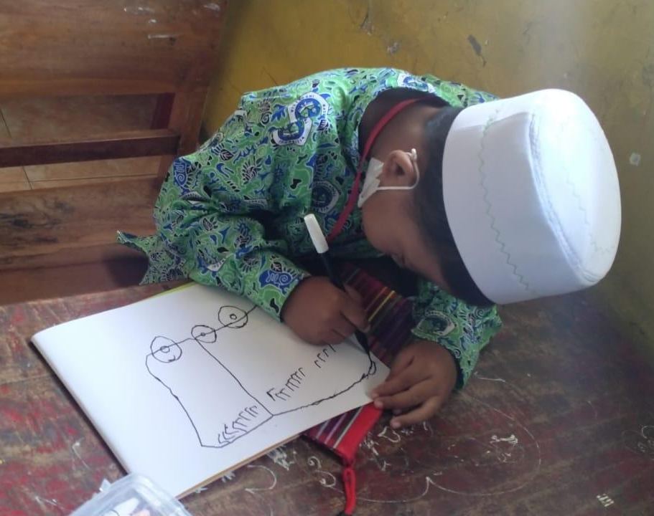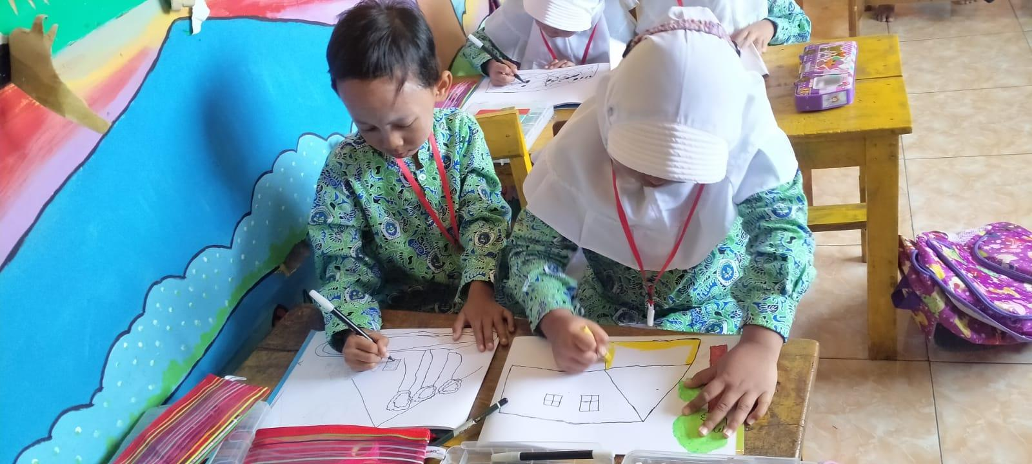
The results of this study are as follows: 1. The effect of drawing activities can stimulate children's creativity. 2. With drawing activities children are more creative and confident. 3. Drawing activities become a teacher's tool to increase children's creativity. 4. Drawing activities can be used as a fun and interesting medium for children's learning.
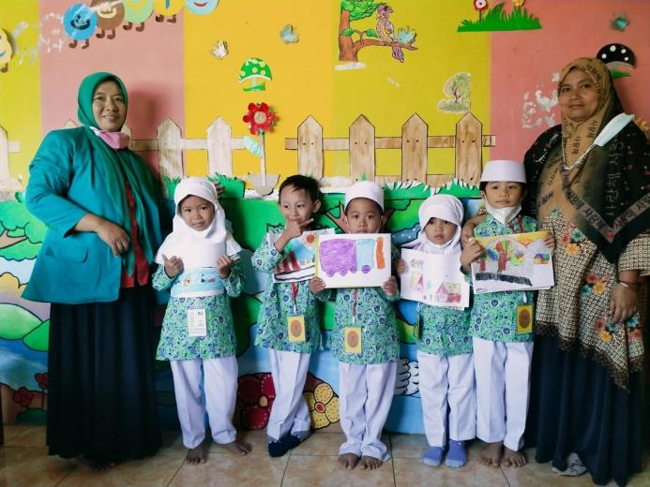
Based on the results of action observations, it can be stated that there is an increase in art in children, both the process and the results of artistic values ​​in children through drawing freely from cycle I to cycle II. Broadly speaking, this research has succeeded in answering the formulation of the problem that has been put forward by the researcher. The formulation of the problem is: "Can free drawing improve children's art"? The answer to the formulation of the problem above can be described as follows: Classroom action research to improve children's art of free drawing at RA Alkaromah Pandan was carried out in cycle II. Each cycle is carried out in four stages, namely (1) the action planning stage, (2) the action implementation stage, (3) the observation stage, and (4) the analysis and reflection stage.

DISCUSSION
The research that has been done is classroom action research which consists of two cycles. Each action cycle consists of four stages, namely planning, implementation, observation and reflection. The results of observations in the form of data are used by researchers to determine the improvement of art in children. At the time before the action is carried out, children's art is in the criteria of starting to develop.
The drawing activity in this study was carried out on a free theme. Drawing activities use the game method, and the activities are fun, so that they can increase their creativity and children can create varied, unique and interesting works. Drawing activities give children the freedom to draw according to the child's ideas. Children are free to draw whatever they like to help develop the creative aspect. Children can combine various colors that have been provided by the teacher with various variations. Children can communicate their work to the teacher and friends in their class, both in the form of pictures that he makes and coloring with various color variations and the child's feelings during drawing activities. In addition, in drawing activities,
Creativity comes from the word creative. In the Big Indonesian Dictionary, creative means having the power to create, having the ability to create. So, creativity is a condition, attitude or situation that is very special in nature and is almost impossible to formulate completely. According to James j. Gallagher, (in Rahmawati & Kurniawati, 2011:13) says that creativity is a mental process carried out by individuals in the form of ideas, new, old products or a combination of the two which will ultimately stick to them.
Drawing in a narrow sense is an activity to realize dreams (thoughts, feelings) in the form of scratching sharp objects (pencils, crayons, chalk, etc.) on flat surfaces (paper, boards, walls, etc.) line element. Free drawing according to Sumanto (2005:6) is a type of drawing as a manifestation of certain feelings that are carried out freely and individually. Free drawing is a drawing activity with the child's imagination as desired and can bring up creative ideas in the form of new images.
This means showing that drawing activities are a teacher's tool to increase children's creativity, so that more or less it will make it easier for children to learn in drawing activities and can be used as a fun and more creative child's learning media in interesting drawing. Suggestions addressed to teachers should pay more attention to interesting and fun learning media for children. Children are more emphasized to draw freely according to what is in the child's imagination / ideas that can be poured into pictures, so that children are more creative in drawing even without using the media that is at school. In this drawing activity, children will know more about their own work and media/drawing activities are very appropriate to develop early childhood creativity.

CONCLUSION
It can be concluded that in the free drawing activity, each child's drawing varies. This is because in the process of creativity, children are given the freedom to create what is in the imagination according to the ideas and experiences of each individual. The use of the free drawing method can increase children's courage to learn creative abilities. This is because the free drawing method, a method given in learning makes the class more active, interesting, and challenging passionately in carrying out learning activities.

Reference list

Isha, Siti. Etc. 2014. Development and Basic Concepts of Early Childhood Development. South Tangerang: Open University.

Anisah, Khoirul Unsin. 2011. Descriptive Analysis of Interpersonal Communication in Teaching and Learning Activities Between Teachers and Early Childhood Early Childhood Students Prima in the Process of Children's Character Formation. Yogyakarta: National Development University “Veterans”.

Ayuningtyas, Devi Nur'aini. 2014. The Ability to Draw Using a Syringe Technique in Group B Children at State Kindergarten 3 Slemanpakemsleman. Yogyakarta: Yogyakarta State University.

Barnawi, Wiyani Novan. 2016. Early Childhood Format. Yogyakarta: Publisher Ar-Ruzz Media.

Hanafi, et al. 2016. Guidelines for Thesis Writing. Jember: Muhammadiyah University of Jember.

Indriyanti, Dian Ulfa. 2016. Improving Children's Creativity through Free Drawing in Group B Children at Al-Kautsar Babatan Jenggawah Early Childhood Education, Jember Regency, 2015-2016 Academic Year: Muhammadiyah University of Jember.

Jamiati. 2011. Children's Art Skills. UPBJJ. Surabaya: Open University. Montolalu, et al. 2007. Children's Play and Games. Jakarta: Open University.

Nurfatoni, Septian. 2013. Study of Expression of Work at Elementary School Level. Bandung: Indonesian University of Education.

Nurkholila, Siti Nenden. 2013. Cultural Dance Appreciation in Tarawangsa Art to Ananda PAUD Students.

